Database: sport_equip_db

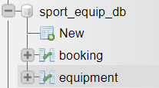

1. Check availability of equipment. By click the button.

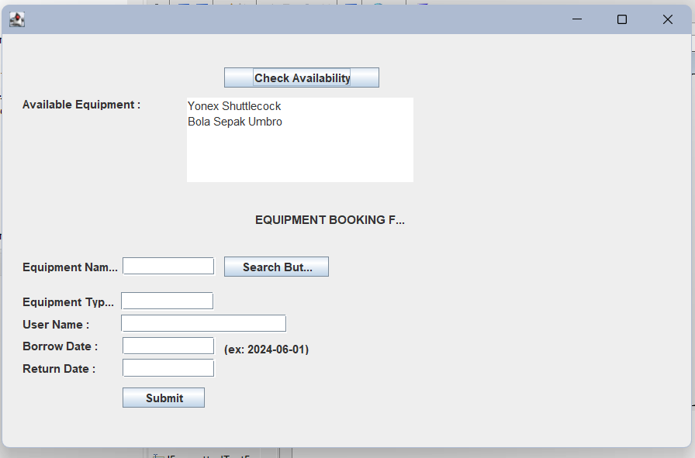

1. Table equipment.

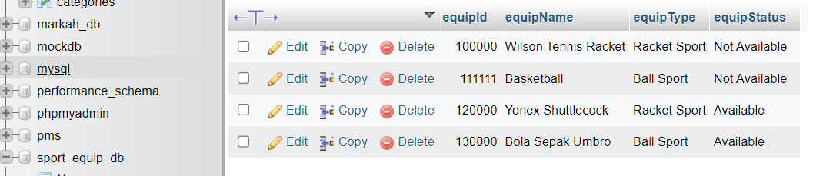

1. User need to key in equipment name and click button search button first. Function of search button is to display equipment type that user already choose.

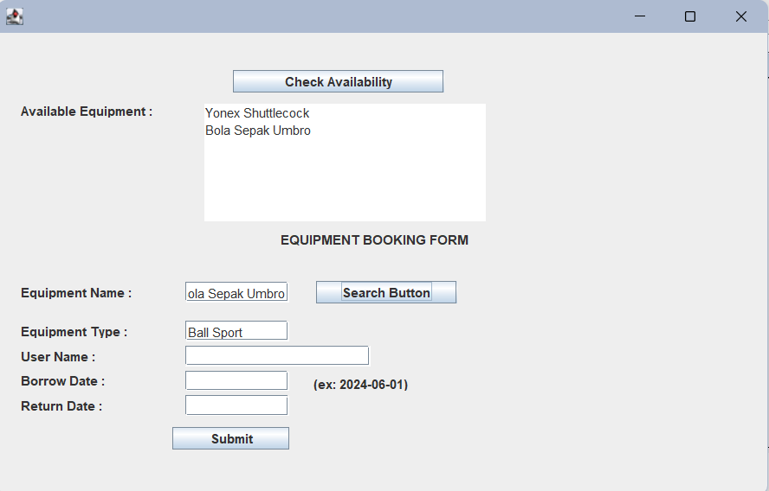

1. After that, user need to fill the form to make a booking of the equipment. After click submit button, the data will save in database table booking.

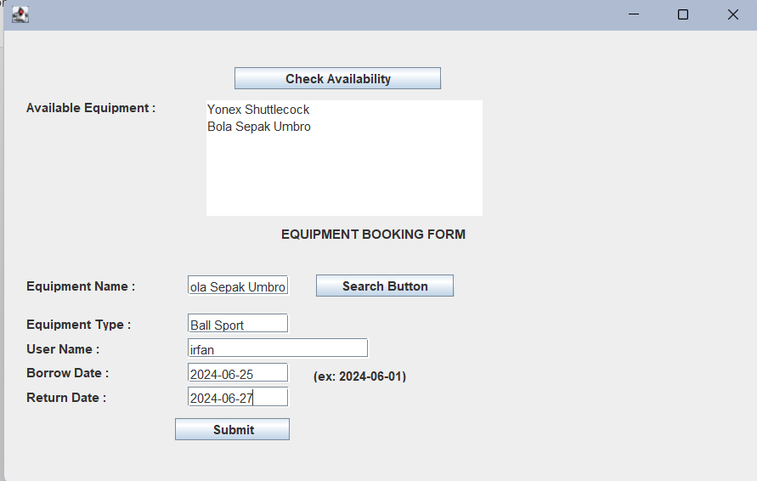

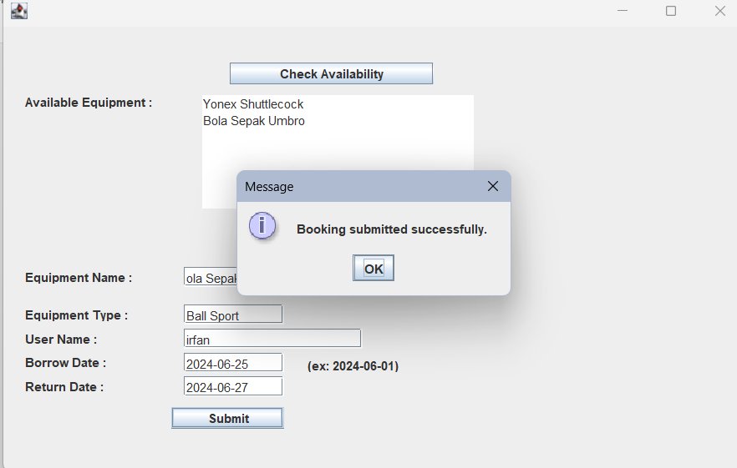

1. Table booking.

